

User Manual

Cabin Control Software

IA2-7-16

2016

Table Of Contents

1 Introduction 3

1.1 About The User Manual 3

1.2 Quick Install Guide 3

2 Getting Started 4

2.1 Logging In 4

3 User Operations 5

3.1 Edit User Information 5

3.2 View Real Time Temperatures 5

3.3 Subscribe And Activate Alarms 6

3.3.1 Temperature Alarm 6

3.3.2 Motion Alarm 7

3.4 Generate Report 7

3.4.1 Send Report to Email 8

3.4.2 Save Report to Computer 8

3.4.3 Print Report 8

4 Extended Administrator Operations 9

4.1 User Controls 9

4.1.1 Add User 9

4.1.2 Delete User 10

4.2 View System History 10

4.2.1 Alarm History 10

4.2.2 Messages History 10

4.2.3 Temperature History 10

4.3 Set Temperature Log Interval 10

5 Troubleshooting 12

6 Contact Us 13

# Introduction

Welcome to Cabin Control! The software that provides an easy to use interface for security and temperature monitoring at your cabin. With online database functionality, you are able to log in from anywhere on the planet and get real time temperature readings, update your alarm and notification settings, get complete system history and generate complete reports which can then be sent directly to your email. Cabin Control is the complete solution for cabin monitoring.

## About The User Manual

This user manual covers all features included in the Cabin Control software.

## Quick Install Guide

*Quick install guide

# Getting Started

Once you have successfully installed the Cabin Control software on your computer, you are ready to access the system and start monitoring your cabin.

## Logging In

Once you launch the program, you will be greeted by the log in screen shown in fig 1.1. In order to log in to the Cabin Control system, you are required to have a valid user account. If you have not been assigned a user account, or you have forgotten your login information, please contact the administrator.

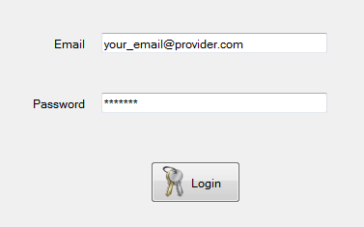

Figure 1‑1: To log in, type in your registered email and password, and click the Login button

# User Operations

Once you have logged in as a user, you will have access to the user control panel and its features.

## Edit User Information

You can change your user information by selecting the “Edit User” tab found on the top of the program window, as illustrated in fig 2.2. Here you can update your name and contact information. If you would like to change the email address affiliated with your user account, please contact the administrator.  
When you are satisfied with your changes, click the “Commit Changes” button.

Take notice of the following:

If you have subscribed to SMS alarm notifications, these notifications will be sent to the phone number affiliated with your user account.

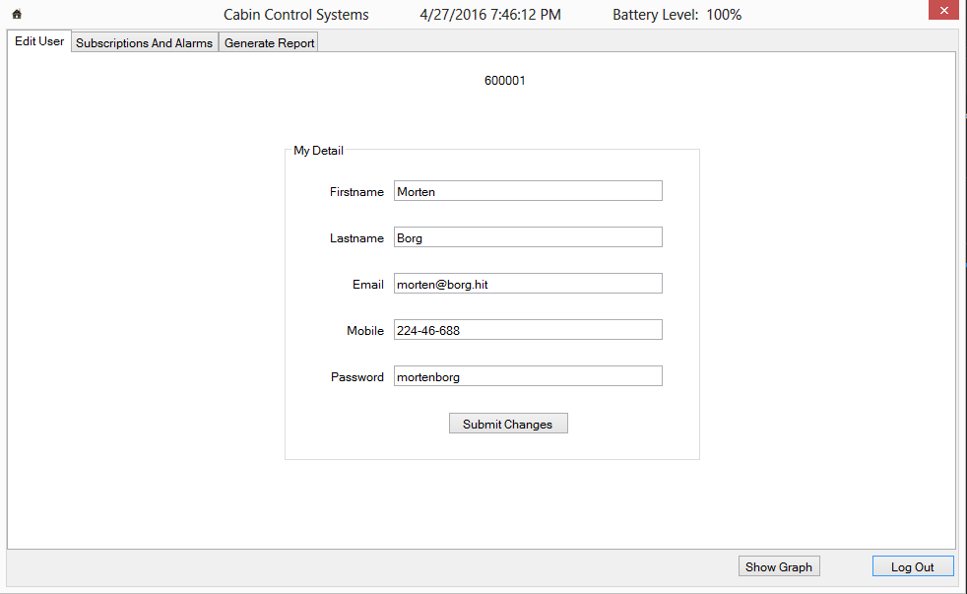

Figure 2‑2: The Edit Report window. Here you can update your user account details and contact information.

## View Real Time Temperatures

The Cabin Control system also allows the user to view a real time temperature graph, updated with temperature values from the central every 30 seconds. This can be accessed by clicking the “Show Temp Graph” button on the bottom of your main form. This will open a new form with the temperature graph shown in fig 2.3 below:

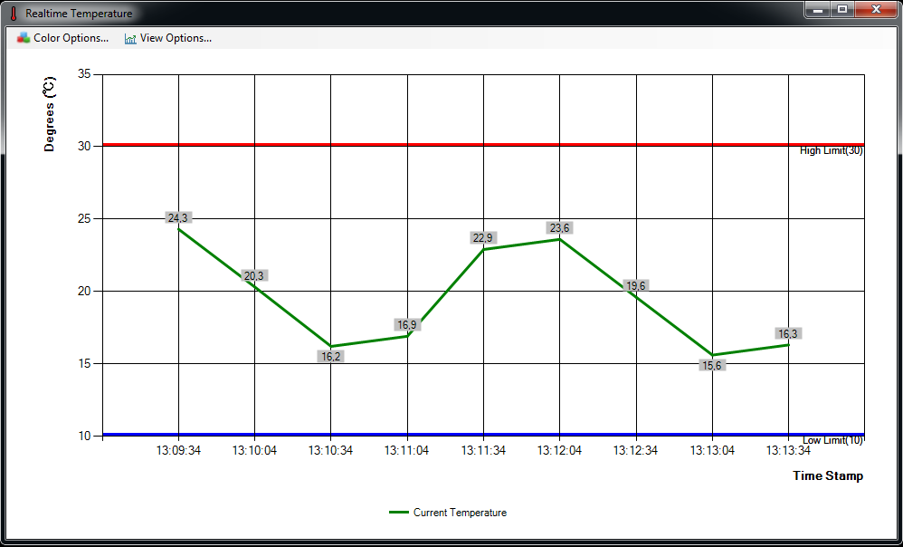

Figure 2‑3: RealTime Temperature window

The green line represents the temperature values measured at the given time in relation to the time stamp axis. If you have activated a temperature alarm, your limit(s) will also be displayed visually on the chart area, here shown by a red and blue line.

In the top left corner of the RealTime Temperature window, you have options to change the chart area’s colors and view:

**Color Options**

|  |  |
| --- | --- |
| **Current Temperature** | Sets the color of the current temperature line. |
| **High Limit Line** | Sets the color of the high limit line |
| **Low Limit Line** | Sets the color of the low limit mine |
| **Value Labels** | Sets color of the value labels shown along the current temperature line |

**View Options**

|  |  |
| --- | --- |
| **Hide Labels** | Toggles the value labels shown along the current temperature line on or off |
| **Change View Scale** | Sets the upper and lower scale of the chart area, as well as the scaling interval |
| **Turn Automatic Scaling ON** | Toggles automatic scaling of the chart area based on value on or off |

## Subscribe and Activate Alarms

In order to subscribe to the available system alarms and set their respective limits, choose the “Subscriptions and Alarms” tab found on the top of the program window, as illustrated in fig 2.4.

This tab will display all available alarms for your system.

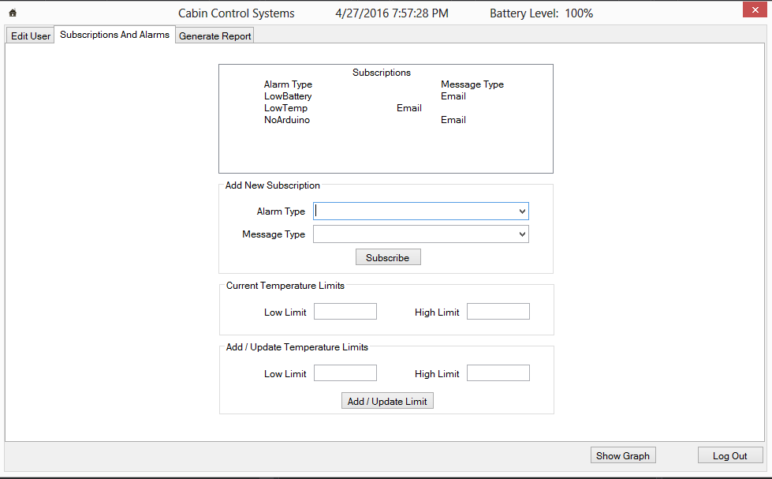

Figure 2‑4: Subscriptions and Alarms page. Here you can subscribe to the alarms of your choice, change alarm settings and choose how you would like to be notified when alarms are triggered.

### Temperature Alarm

The Cabin Control system allows a user to set an upper and/or lower limit and be notified when the temperature exceeds the chosen limit(s). In order to activate the temperature alarm, click the “Activate Temperature Alarm” checkbox. You will then be able to set your wanted limit(s) and choose how you wish to be notified when the alarm is triggered. If you wish to deactivate an active temperature alarm, simply uncheck the “Activate Temperature Alarm” checkbox. To save your settings and activate the alarm, click the “Save Settings” button.

### Motion Alarm

The Cabin Control system also has a motion detector connected to its central, which allows the detection of movement at its location. In order to activate the motion detection alarm, click the “Activate Motion Alarm” checkbox. You can then choose how you wish to be notified when the alarm is triggered. If you wish to deactivate an active motion alarm, simply uncheck the “Activate Motion Alarm” checkbox. To save your settings and activate the alarm, click the “Save Settings” button.

## Generate Report

If you want to create a report of your individual alarm history, you can do so in the “Generate Report” tab found at the top of the program window, as shown in fig 2.5. You can sort the data by selecting the timespan you are interested in from the date picker on the far right side.

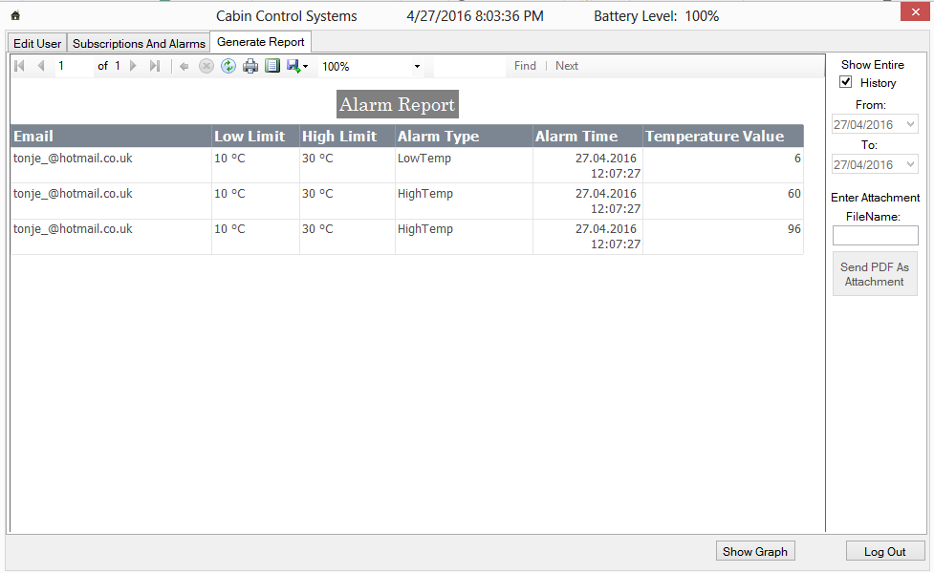

Figure 2‑5: The Generate Report window. Sort your report data based on the categories shown in the top right corner

### Send Report to Email

You can send the report to the email registered to your account. First, enter the name you wish to give to your file into the input box located on the mid-right of the “Generate Report” window. After entering a name, the “Send PDF As Attachment” button found directly underneath will now become active. Click the button and your report will be formatted as a PDF file and sent to you as an attachment.

### Save Report to Computer

You can also save the generated report to your computer by selecting the “Export” button on the report toolbar, illustrated in fig 2.6.

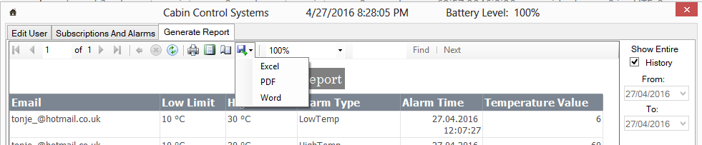

Figure 2‑6: Save the generated report to file

You can chose what in format you wish to save the report, but PDF is recommended for readability.

### Print Report

Finally, you can choose to print the generated report. To do this, click the “Print” button found on the report toolbar, as shown below in fig 2.7.

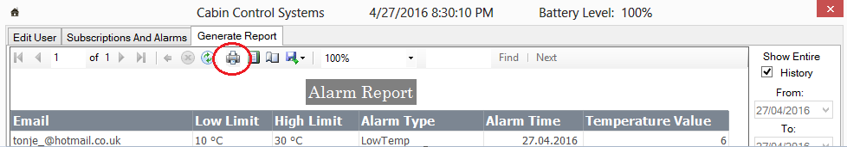

Figure 2‑7: Print the generated report

# Extended Administrator Operations

As an administrator, you have an extended set of operations in addition to the user operations explained in Chapter 2: User Operations.

## User Controls

The User Control Panel contains all information about the registered users affiliated with your system. To either add, edit or delete a user, select the “User Control Panel” tab on the top of your program window, as illustrated in fig. 3.1 below:

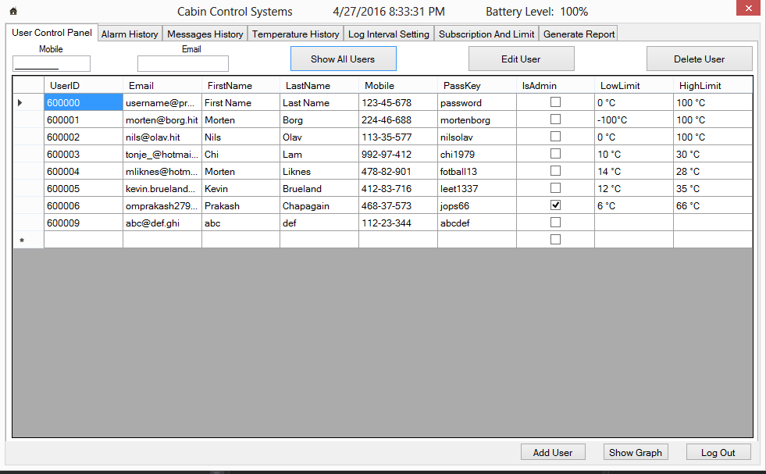

Figure 3‑1: User Control Panel. To display all registered users, click the “Show All Users” button.

### Add User

To add a new user, click the “Add User” button located in the lower left corner of the User Control Panel. The panel in fig. 3-2 will appear.

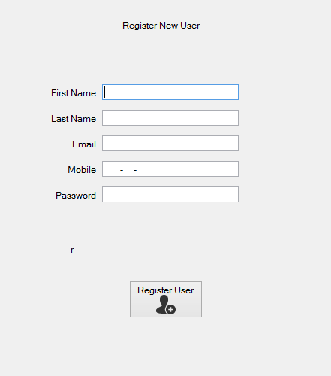

Figure 3‑2: Register a new user

Once you have entered the user information, click the “Register User” button to complete the registration. The email registered to the user account, will also serve as the account username, and will be affiliated with the email alarm notifications, should the user choose to subscribe to this service.

### Delete User

If you want to delete a user, select the user from the user list and click the “Delete User” button located on the top right of the User Control Panel as shown in Figure 3.3. You will be asked to confirm the action before the user is deleted. Once the user has been deleted, he cannot be restored by other means then adding him as a new user.

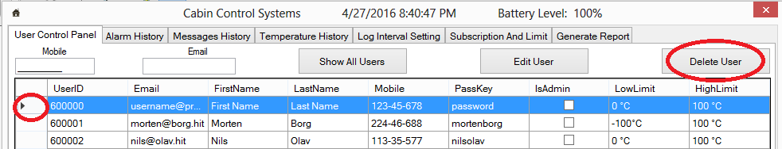

Figure 3‑3: To delete a user, select the user by clicking the far left column corresponding to the row of the user. The entire row will be highlighted. Next, press the "Delete User" button.

## View System History

You can get complete temperature, alarm and messaging history for all registered users by selecting either the “Alarm History”, “Message History” or “Temperature History” tab on the top of the program window.

### Alarm History

To view the complete alarm history, click the “Show All Alarms” button. This will display all triggered alarms and the user it is related to, along with the time it was triggered and its unique alarm ID. See Figure 3.4

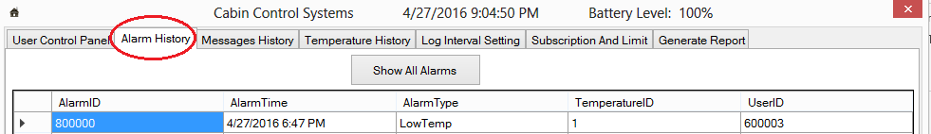

Figure 3‑4: Display the Alarm History.

### Messages History

To view the complete messaging history, click the “Show All Messages” button. This will display all alarm messages that have been sent from the system to the users, and display what type of message it was along with its unique message ID. See Figure 3.5

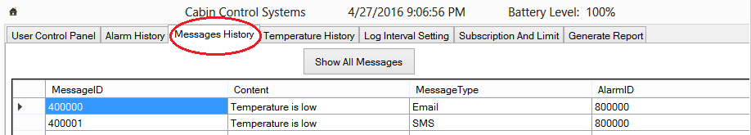

Figure 3‑5: Display Message History.

### Temperature History

To view the complete temperature history, click the “Show All Temperatures” button. This will display all logged temperature values along with the log time and unique ID. See Figure 3.6

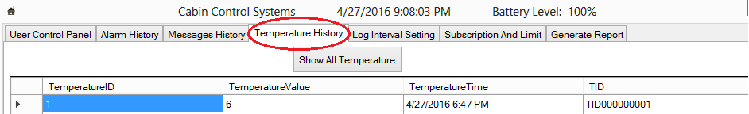

Figure 3‑6: Display Temperature History.

## Set Temperature Log Interval

To set the time interval in which the system logs temperatures to the database, select the “Log Interval Setting” tab on the top of the program window. The panel in Figure 3.5 will appear.

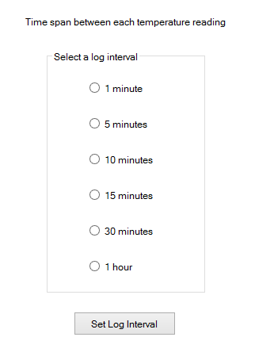

Figure 3‑5: Set the temperature log interval

Select the interval time and click “Set Log Interval” to confirm.

# Troubleshooting

This chapter will address the most common problems you might experience when using the Cabin Control software. It will be presented in a Q&A style.

*Add this if needed*

# Contact Us

Feel free to contact us should you need any information or if you are experiencing any problems with our product.

* *Support & General:*

+004746837573 (24/7)

* *Email:*

Support@CabinControl.com